Name:ABINAYA K  abinayak.ai@sairam.edu.in  SECT25AI03 | 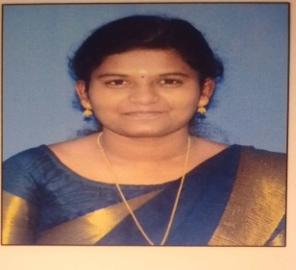
Designation: | Assistant Professor(Artificial Intelligence & Data Science)
Area of Specialization: | Programming in Python,Deep Learning.
Experience | Teaching:1.10 years.  Research : Nil  Industrial Experience: Nil
No of Workshop/FDP attended: | No of Workshop | No of FDP
No of Workshop/FDP attended: | Nil | 02
1.Journal  2.Conference  3.Patents | National | International
1.Journal  2.Conference  3.Patents | Nil | Nil
Professional body membership | --
Awards and Achievements | Got Appreciation and reward for achieving 98% result in Anna University examinations for the subject of Object-Oriented Software Engineering.
Publications  - Journal  2.Conference  3.Patent | Nil

LISTOFSEMINAR/SHORTTERMCOURSES/FDP/WORKSHOPATTENDED

Attended online FDP on"ciper wise EDU”, organized by Satyabama institute of

science and technology from 08-01-2024 to 12-01-2024.

Attended online FDP on"AI nexus -Advanced AI education" ,organized by

Satyabama institute of science and technology from 08-01-2024 to 12-01-2024.

EDUCATIONALQUALIFICATION

Degree | Year of Passing | Discipline | University & Institution | Percentage & Class Obtained
Ph.D | - | - | - | -
M.E | 2023 | CSE | Loyola Institute of Technology and Science,Nagerkoil. | 8.6–First Class
B.E | 2021 | CSE | RVS College of Engineering and Technology,Coimbatore. | 7.96-First Class
HSC | 2017 | Bio-Maths | Gramma Committee Hr.Sec.School. | 78% -First Class
SSLC | 2015 | Bio-Maths | Gramma Committee Hr.Sec.School. | 95%-First Class

Declaration: I hereby declare that all the information mentioned above is true to my knowledge and I have all supporting documents for the facts mentioned above.

(K.Abinaya)

